|  |  |
| --- | --- |
| Date | 26 October 2022 |
| Team ID | PNT2022TMID15139 |
| Project Name | Smart Farmer - IoT Enabled Smart Farming Application |

**IBM CLOUD SERVICES:**

**DASHBOARD:**

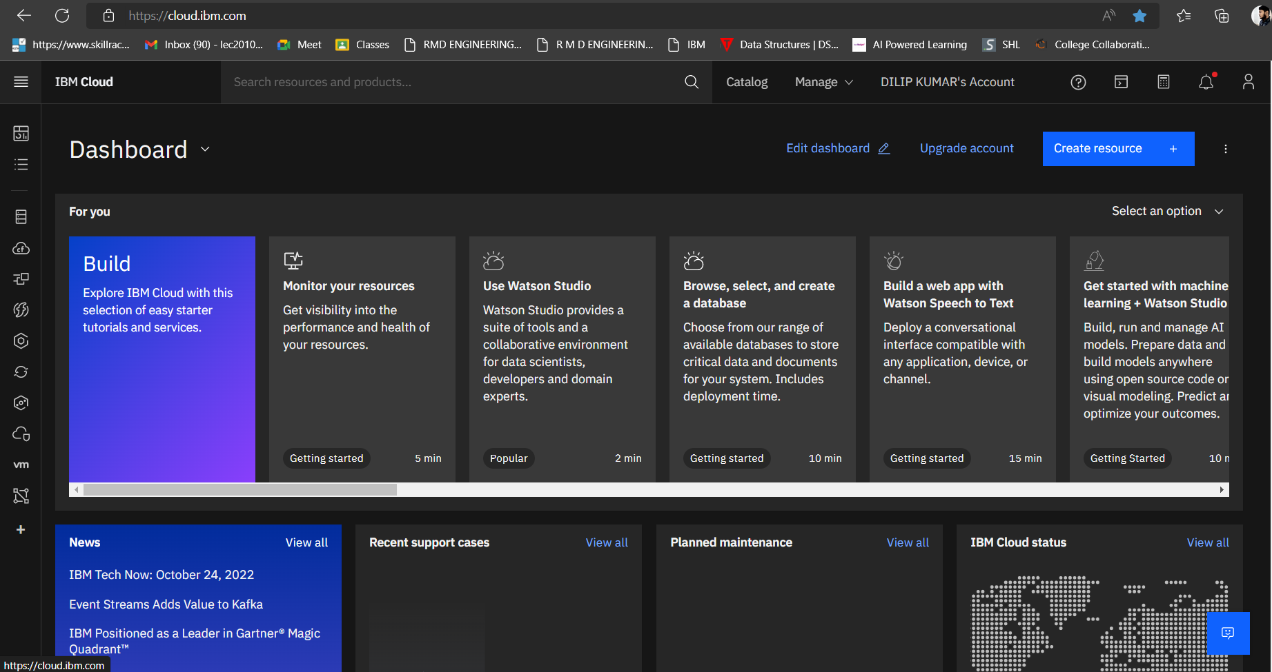

**ACCOUNT INFORMATION:**

